It is with utmost respect and profound gratitude that the Ministry of Finance of the Government of Tonga submits this Press Release appertaining the Tonga Volcanic Eruption and Tsunami Assistance Account

PRESS RELEASE

TONGA’S VOLCANIC ERUPTION AND TSUNAMI ASSISTANCE ACCOUNT

26th January, 2022

Nuku’alofa

The people of Tonga are still overwhelmed with the impact of a volcanic eruption at Hunga Tonga – Hunga Ha’apai, tantamount to an earthquake, on Saturday evening, 15th January, 2022. The catastrophe triggered tsunami waves, causing illness / injury / death, extensive and catastrophic damages to houses, assets, water & sanitation, vegetation and the environment. Most devastated were nearby islands in Ha’apai, ‘Eua, ‘Atata, and west and north coast of Tongatapu. This was further severed by international and domestic communications breakdown. Residents of the islands of Mango, and ‘Atata were immediately evacuated and re-located to Tongatapu, due to complete destruction of housing, water and sanitation. Hence, the State of Emergency declaration effective on Sunday 16th January, 2022.

The Government of Tonga is grateful for the immediate concern and rapid response of the International Community, Development Partners, and the Tongan Diaspora. All donations will be committed to the recovery and reconstruction post the eruption, and accounted for, using the Government financial management and reporting requirements. A Volcanic Eruption and Tsunami Assistance Account has thus been opened at the Bank of South Pacific Tonga Ltd. (BSP) at Nuku’alofa and can receipt donations from anywhere as per the details on ANNEX I. If any problem arises in accessing the Account in reference, please do not hesitate to contact any of Tonga’s 9 diplomatic missions overseas with corresponding accounts listed in ANNEX II.

ANNEX I TONGA VOLCANIC ERUPTION & TSUNAMI ASSISTANCE ACCOUNT

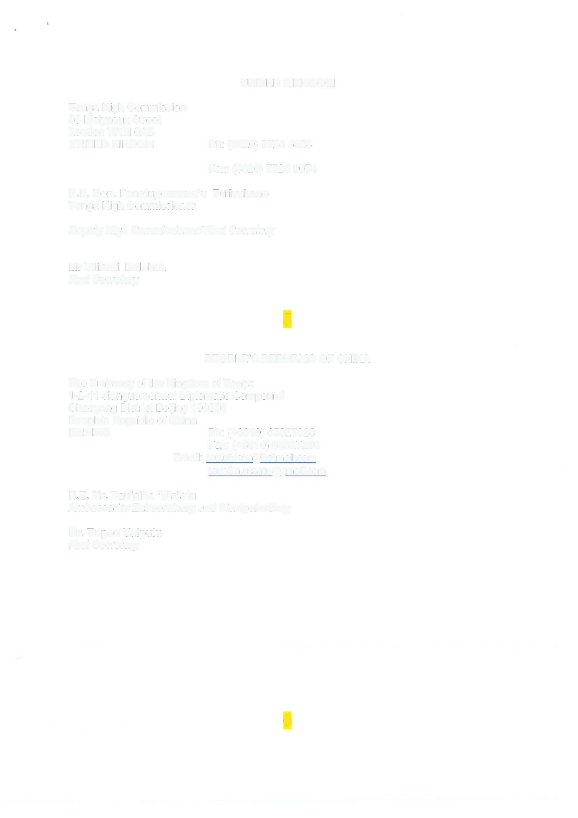
ANNEX II - TONGA’S DIPLOMATIC MISSIONS CONTACT DETAILS

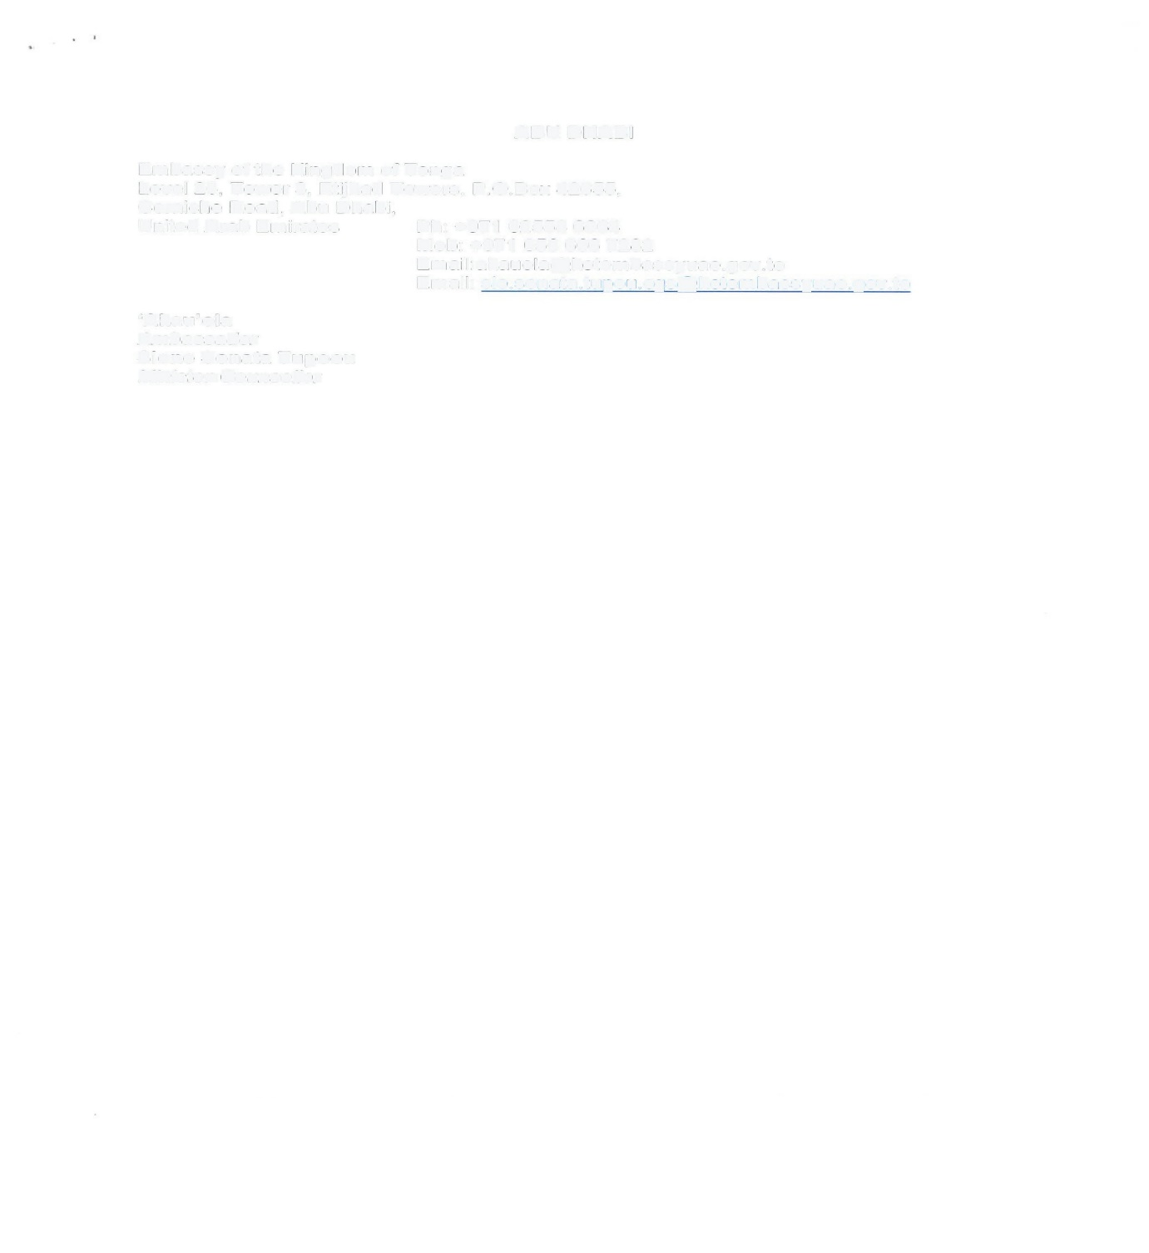
1. UNITED STATES OF AMERICA
Permanent Mission of Tonga to the United Nations
250 East 51 st Street
New York, NY 10022
UNITED STATES OF AMERICA Ph: (001917) 369 1025 Fax: (001917) 369 1024

H.E. Mr. Va'inga Tone
Ambassador to the United Nations and United States,
High Commissioner to Canada
Deputy Permanent Representative
Ms Jeanett Vea
First Secretay
Ms Darlene Vaea
First Secretary
2. SAN FRANCISCO, USA
Consulate General of the Kingdom of Tonga
360 Post Street
Suite 604
San Francisco 94108
UNITED STATES OF AMERICA Ph: (415) 816 9132 Fax: (415) 781 3964

Mrs. Sela Tukia
Acting Consul General
Miss Lisa Kupu
Administrative Assistant
3. HAWAII, USA
Consular Agency of the Kingdom of Tonga
738 Kaheka Street
Suite 3068
Honolulu, HAWAII 96814
UNITED STATES OF AMRERICA Ph: (808) 953 2449 Fax: (808) 955 1447
Ms. Annie M. Kaneshiro
Consular Agent

4. UNITED KINGDOM
Tonga High Commission
36 Molyneux Street
London W1H 6AB
UNITED KINDOM Ph: (4420) 7724 5828 Fax: (4420) 7723 9074
H.E. Hon. Fanetupouvava'u Tu'ivakano
Tonga High Commissioner
Deputy High Commissioner/ First Secretary
Mr Viliami Lolohea
First Secretary

5. PEOPLE'S REPUBLIC OF CHINA
The Embassy of the Kingdom of Tonga
1-2-11 Jianguomenwai Diplomatic Compound
Chaoyang District Beijing 100600
People's Republic of China
BEIJING Ph: (+8610) 65327028 Fax: (8610) 65327204
Email: tau.utaatu@hotmail.com tauaika.utaatu@gmail.com

H.E. Mr. Tau'aika 'Uta'atu
Ambassador Extraordinary and Plenipotentiary

Mr. Tupou Vaipulu
First Secretary

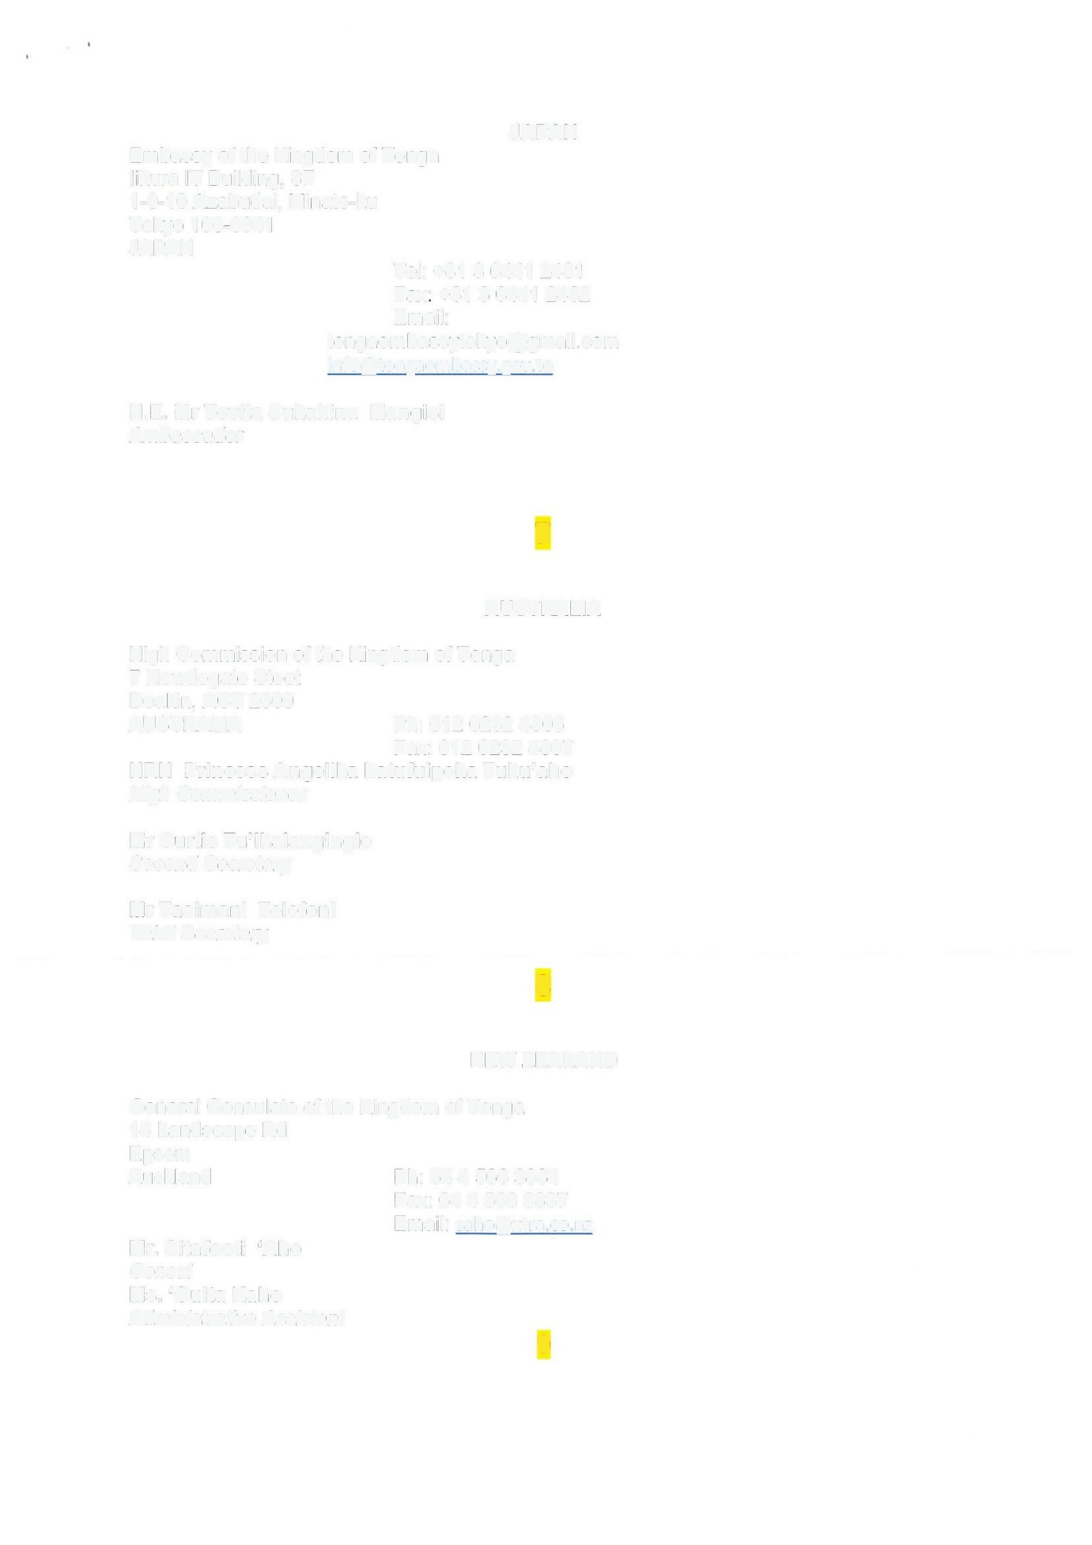
6. JAPAN
Embassy of the Kingdom of Tonga likura IT Building, SF
1-9-10 Azabudai, Minato-ku
Tokyo 106-0041
JAPAN
JAPAN Tel: +81 3 6441 2481 Fax: +81 3 6441 2482
Email: tongaembassytokyo@gmail.com info@tongaembassy.gov.to
H.E. Mr Tevita Sukahina Mangisi
Ambassador

7. AUSTRALIA
High Commission of the Kingdom of Tonga
7 Newdegate Steet
Deakin, ACT 2600
AUSTRALIA Ph: 612 6232 4806 Fax: 612 6232 4807
HRH Princess Angelika Latufuipeka Tuku'aho
High Commissioner
Mr Curtis Tu'ihalangingie
Second Secretary
Mr Tasimani Telefoni
Third Secretary

8. NEW ZEALAND
General Consulate of the Kingdom of Tonga
14 Landscape Rd
Epsom
Auckland Ph: 64 4 566 3884 Fax: 64 4 566 3887
Email: saho@xtra.co.nz
Mr. Sitafooti 'Aho
Consul
Ms. 'Ouita Kaho
Administrative Assistant

9. ABU DHABI
Embassy of the Kingdom of Tonga
Level 26, Tower 3, Etijhad Towers, P.O.Box 42655, Corniche Road, Abu Dhabi,
United Arab Emirates Ph: +971 02558 6664 Mob: +971 056 666 7282
Email:akauola@kotembassyuae.gov.to
Email: sio.sonata.tupou.cqs@kotembassyuae.gov.to

'Akau'ola
Ambassador
Sione Sonata Tupoou
Minister-Counsellor

